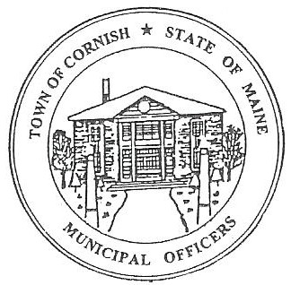 Town of Cornish

**PLANNING BOARD**

17 Maple Street

Cornish, Maine 04020

Telephone: 207.625.4324 Fax: 207.625.4416 E-mail: planningboard@cornishme.com

**BUSINESS MEETING AGENDA**

**5:30 p.m.**

Monday, January 6, 2025

1. **Call to Order**
2. **Adjustments/Additions to the Agenda:**
3. **Communications Received/Sent:**
   1. Les MacMaster /Selectboard
4. **Review of Minutes:**
   1. 12/02/24 to be approved.
5. **Old Business.**
   1. Mary Ghosheh – 166 Main Street – (ref. – U06-005).
      * 1. Fresh Air Home Daycare.
   2. Kathy Libby – 30 Main Street – (ref. – U03-015).
      * 1. Coffee/Snack/Bar.
   3. Sign Ordinance discussion.
   4. Floodplain
      * 1. Needs to be ready for the Town Annual Meeting.

1. **New Business:**
   1. New Cannabis Laws
      * 1. Are they in compliance with our ordinance?.
   2. Vice Chair Eve Bergstrom – Term ends – 03/01/25.
      * 1. She has announced she will be leaving.
   3. M. Angel Eastman -Term ends – 03/01/25.
      * 1. Will return if accepted.
   4. Bob Plourde – Terms ends – 03/01/25.
      * 1. Will return if accepted.
   5. Members not returning – next step
      * 1. Advertising for new members
        2. Associates could step up if they chose to.
        3. Voting on members.
2. **Miscellaneous:**
3. **Public Comment:**
4. **Agenda Items for Next Meeting:** **Workshop – Monday, January 20, 2025 @ 5:30 PM**
5. **Adjournment**