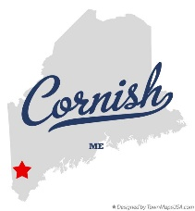**Business Meeting Agenda**

Planning Board

17 Maple Street

Cornish, ME 04020

Telephone: (207) 625-4324

Fax: (207) 625-4416

Email: [planningboard@cornishme.com](mailto:planningboard@cornishme.com)

Website: www.cornishme.com

**5:30 P.M.**

**Monday, February 3, 2025**

1. Call to Order:
2. Adjustments/Additions to the Agenda:
3. Communication Received/Sent:
   1. Frank Perry – Ref – R02- 4B
      1. Scheduled for February 17, 2025, Workshop Meeting
   2. Cultivating Maine’s Agricultural Future
      1. Zoning
4. Review of Minutes: 01-06-25
5. Old Business:
   1. Sign Ordinance
      1. Does the language need to be changed?
      2. The CEO and Board of Appeals need to submit some language.
   2. There will be two open positions on the Planning Board.
6. New Business:
7. Miscellaneous: Reminder – Town Annual Voting – March 15, 2025 @ 2:00 PM – 8:00PM. Annual Town Meeting – March 17, 2025 @ 7:00PM. Both will be held at the Pike Hall.
8. Public Comment:
9. Agenda Items for Next Meeting: Workshop – Monday, February 17, 2025 @ 5:30 PM
10. Adjournment: